**API End Points and Communication**

**Day 15: 25 March 28**

1st project : Eureka Server

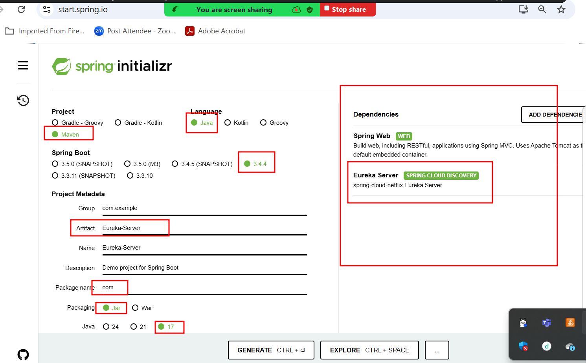

Eureka Server

8761 -🡪 port number

Account Micro Service

8383 port number

Starter 🡪web starter

Starter 🡪 jpa starter

Dependency 🡪 mysql connector

Starter 🡪Eureka discovery client

Create account Post method accno pk, name, emailid(unique),amount

FindBalance get method using accno we find the balance

Withdraw put method accno and amount to withdraw

Deposit put method accno and amount to deposit

FindAccountNumber get method if we pass emalid we want account number

**MySQL -🡪 Database**

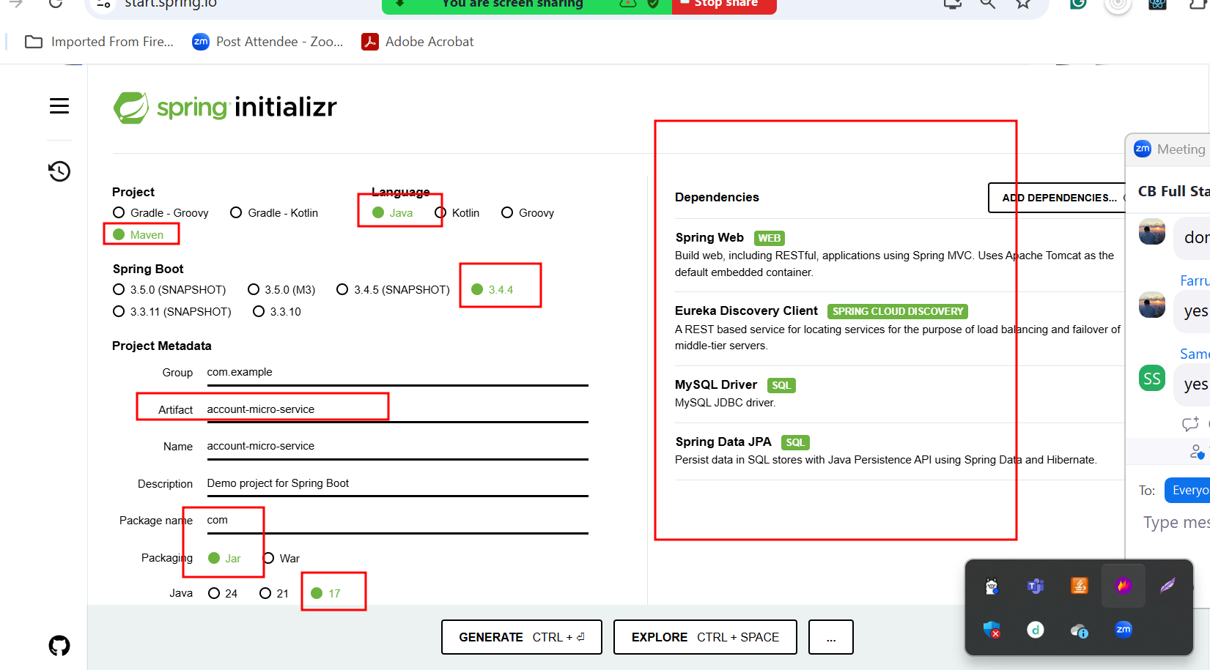

Paypal or Paytm or Gpay

8484 port number

Starter 🡪web starter

Starter 🡪 jpa starter

Dependency 🡪 h2 connector / mysql connector

H2 database (in memory database).

Starter 🡪Eureka discovery client

Create Gpay account -🡪

**H2 🡪 Database in memory database or Mongo DB or any other database.**

Create account -🡪 gpayid auto increment, accnumber :

8484 port number we pass emailid to create paypal account. This emailid pass to 8383 port number for account service to get account number. If account already present that account number and paypal id which created as auto increment we store in h2 database.

While creating gpay or paypal account details we pass emailid and base upon emailid we get account number from account micro service and create the account.

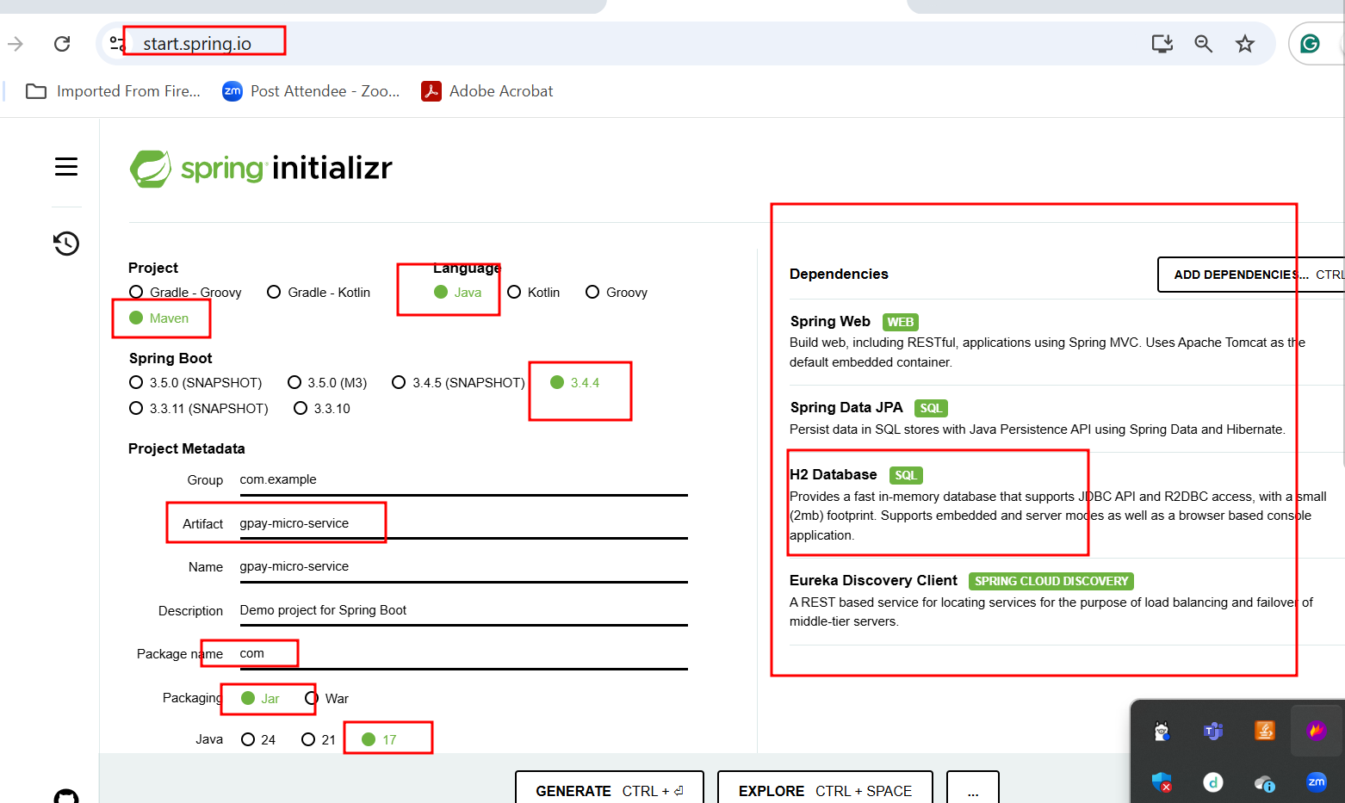

In Spring boot, if one micro service or rest web want to communicate to other micro service or rest api develop using any language we need to use RestTemplate. Inside service layer you need to do auto wired for RestTemplate.

While doing auto wired for RestTemplate spring boot doesn’t provide object. so we need write custom method which help to provide the object of RestTemplate;

Open H2 database on browser mode

<http://localhost:8484/h2-console>